* Consider an example where there’s an account holder table where we are doing an intra bank transfer i.e. a person holding account A is trying to transfer $100 to account B.

Before Transaction

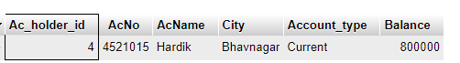



After Transaction

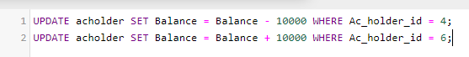

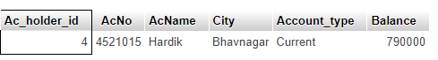

* Also fetch the details of the account holder who are related from the same city

INPUT



OUTPUT

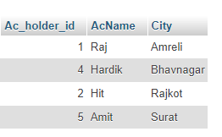

* Write a query to display the city name and count the branches in that city. Give the count of branches an alias name of Count_Branch.

INPUT

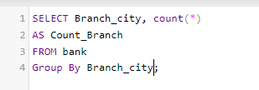

OUTPUT

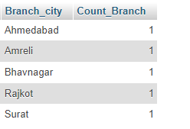

* Write a query to display the account holder’s id, account holder’s name, branch id, and loan amount for people who have taken loans. (NOTE : use sql join concept to solve the query)

INPUT

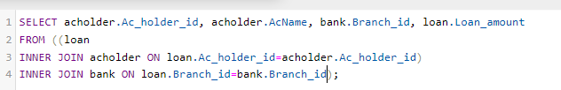

OUTPUT

